**Lab 1 report**

**Task 1 : UMKC VM – Installation**

To install UMKC VM first we need to connect UMKC VPN.

To connect to VPN we need to download VPN and then login in with the SSO.

The login screen looks as below

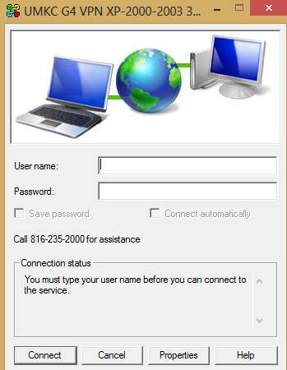:

To login to the cloudera manger,

we need access the following URL

<http://134.193.136.127:7180>

The cloudera manager page looks as below:

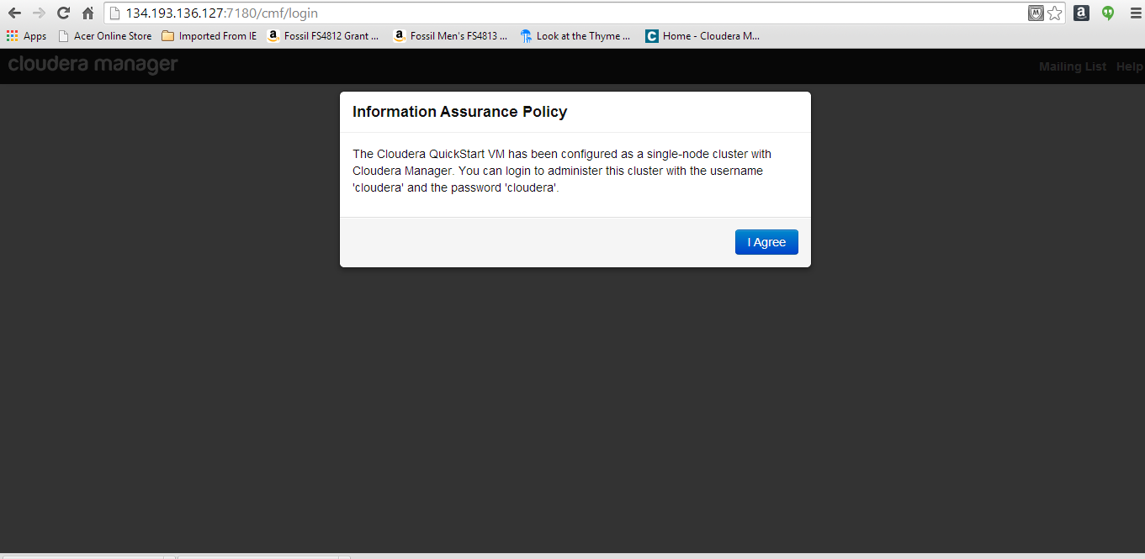

On clicking I Agree we will be redirecting to the login page of cloudera

where we need to login with our SSO as our username and password.

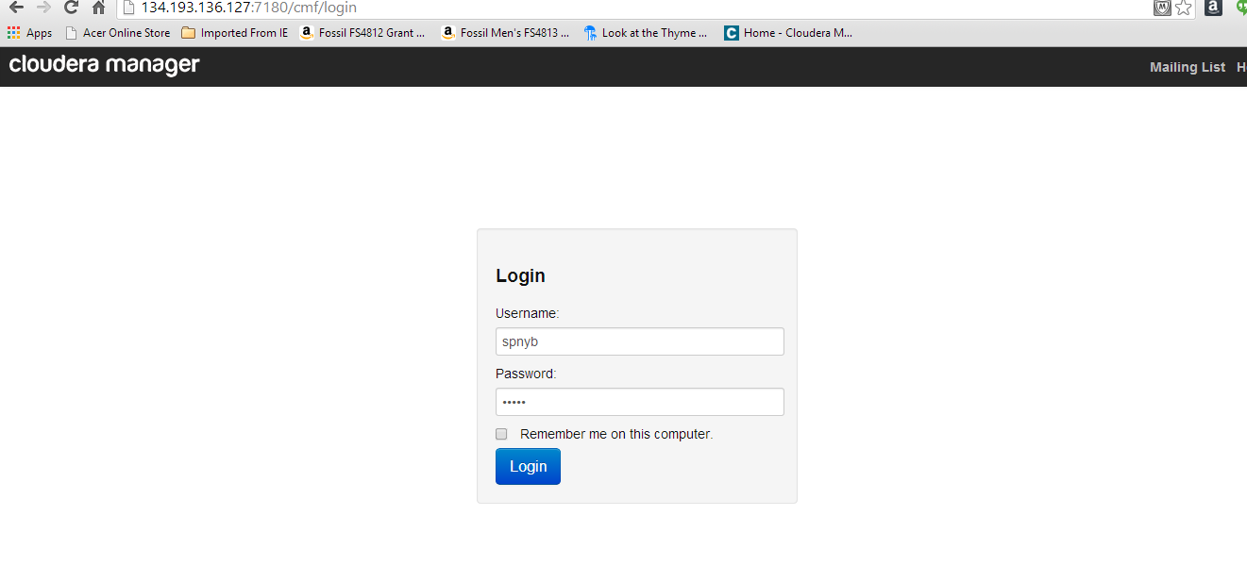

After logging to the cloudera manager the screen shows as below:

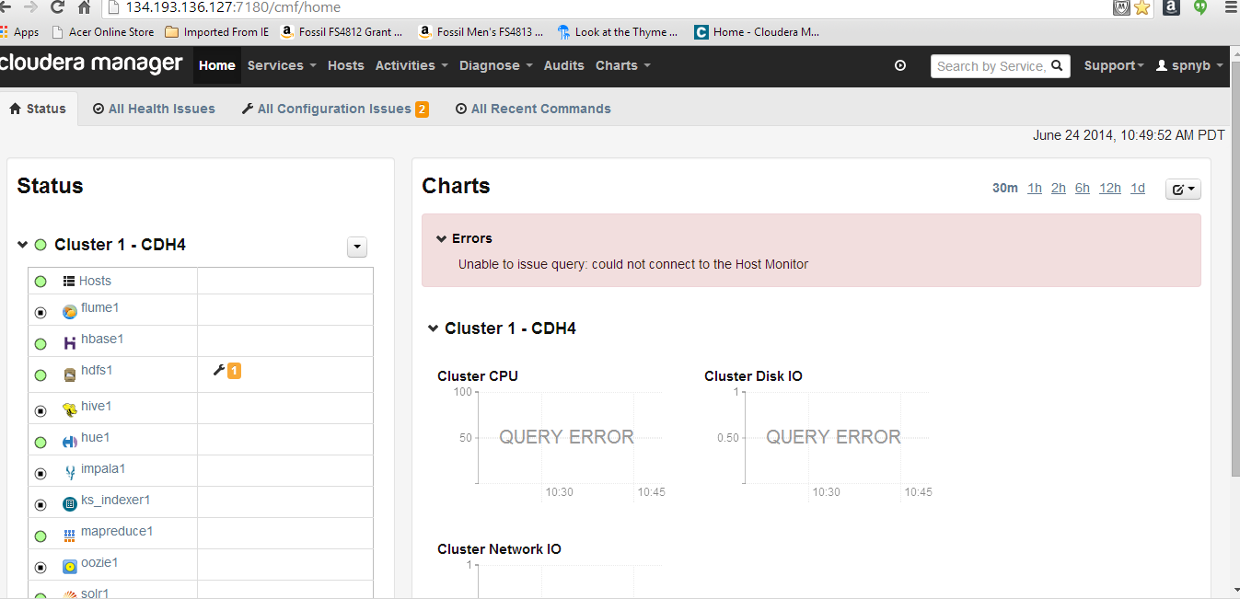

**Task 2:** cloudera/map reduce

First I installed vm player to install cloudera

Then I installed cloudera version 5.0

Then open the image cloudera quickstart-vm 4.4.0.1 vmware

The below screen short shows how to open the file

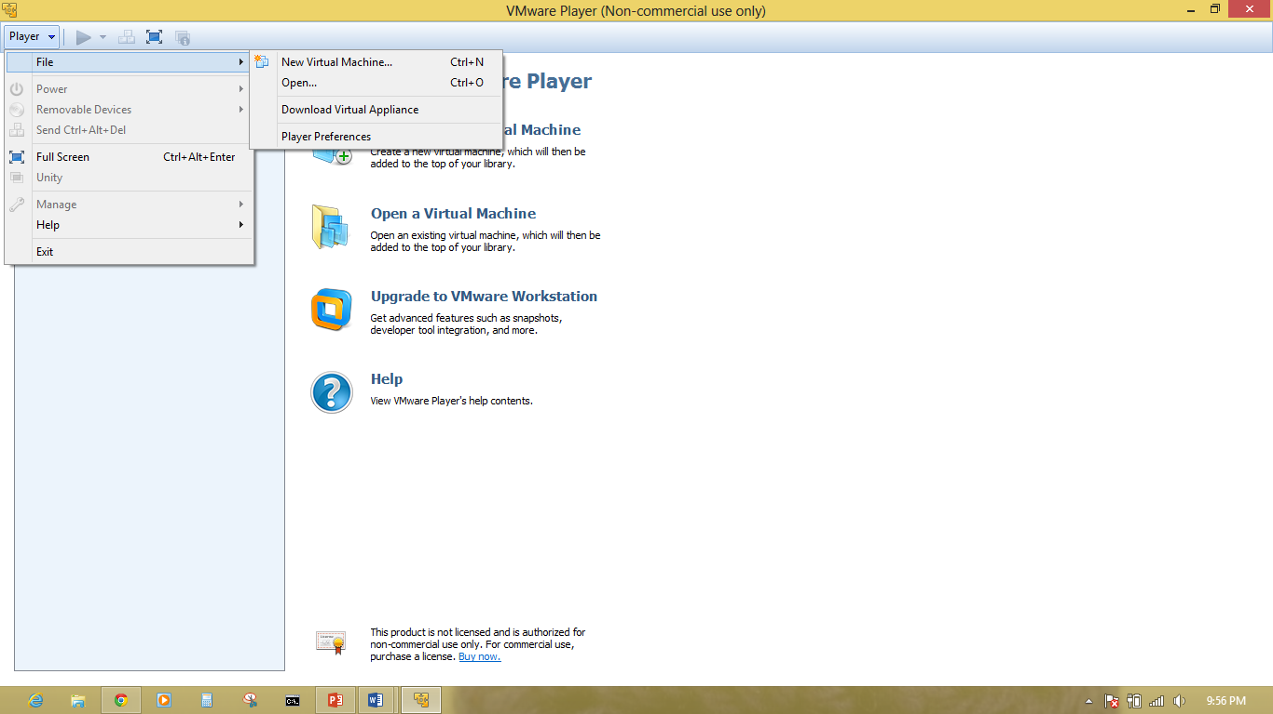

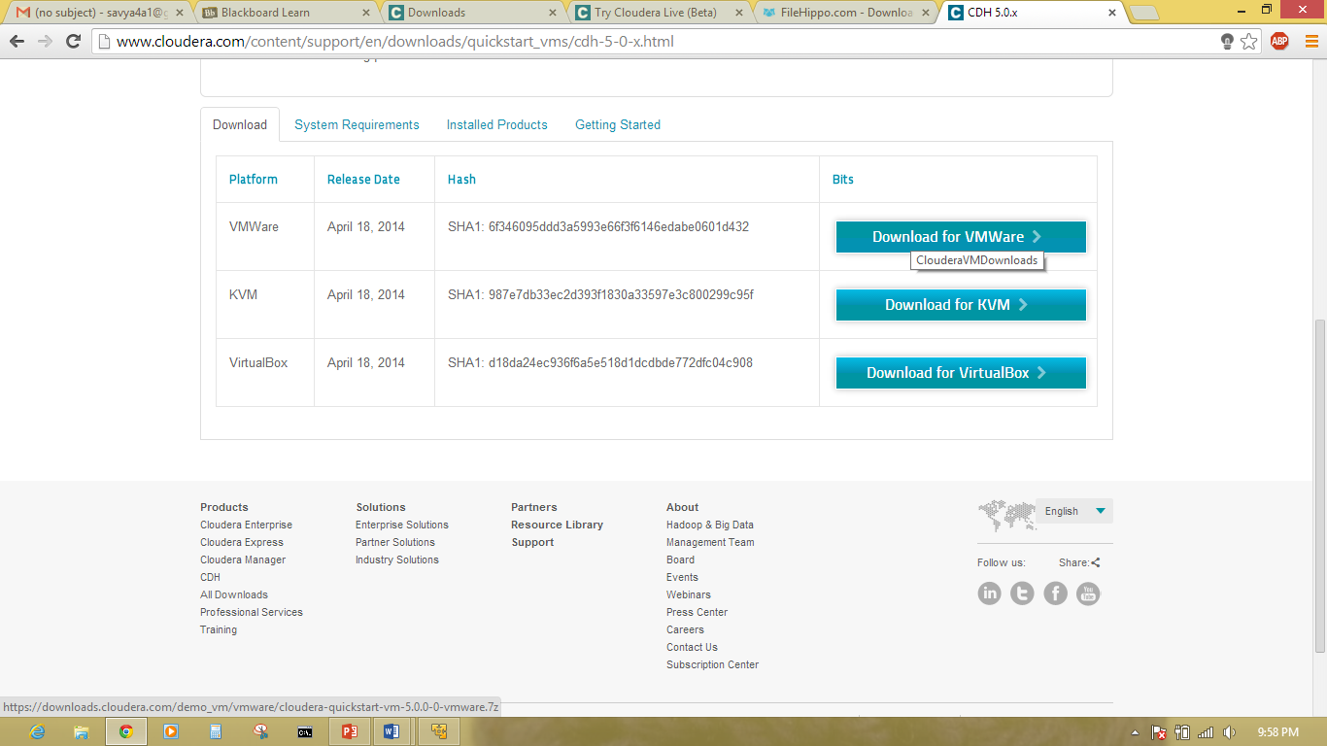

After opening the image cloudera will be installed and will boot to open the virstual machine.

The below screen shot shows the booting of virtual machine

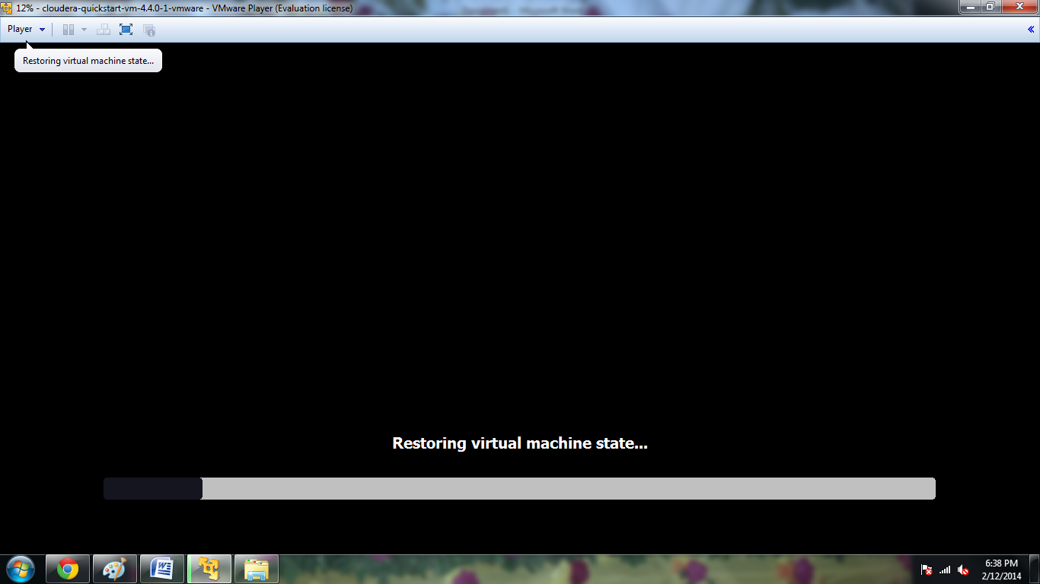

It asks for the login. Then login with Username and Password as “Cloudera”.



The below screen shot shows the upgradation of hosts.

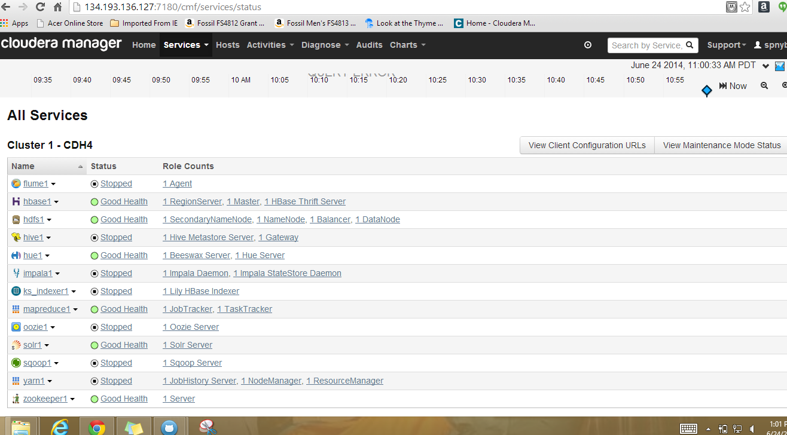

**Subtask -3:**

**File transfer to Cloudera:**

First download the putty and install it.

Putty can be downloaded from the following URL:

<http://www.chiark.greenend.org.uk/~sgtatham/putty/download.html>

enter the host name and click open

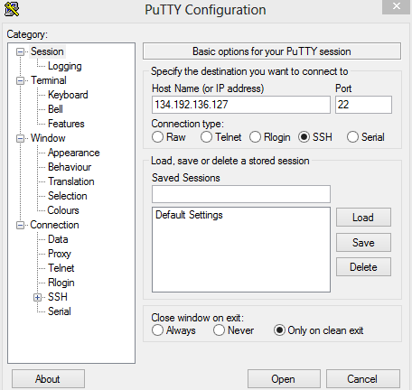

WinSCP is a very easy way to transfer files remotely from win to linux

It can be downloaded from <http://winscp.net/eng/download.php>

Enter the group name and password with host name

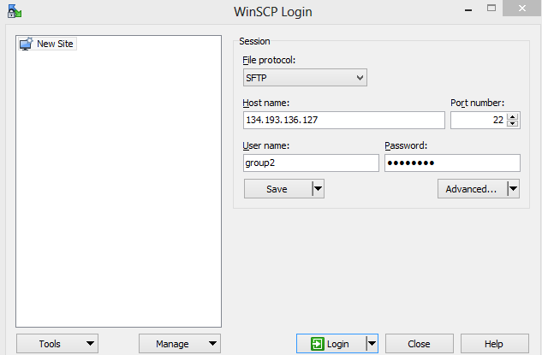

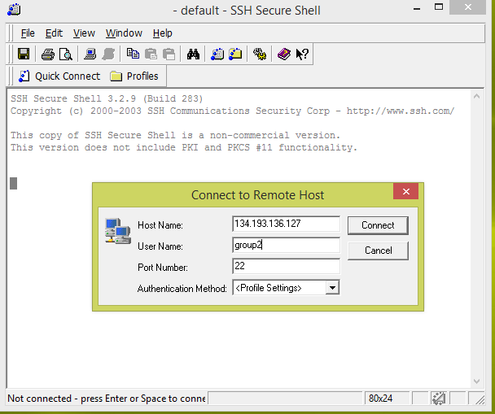

After connecting it then asks for the password for authentication

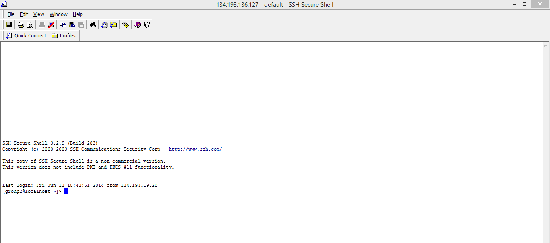

Later all the files will be transfer.

**Subtask – 4: Executing word count example:**

To execute word count example Download the source code of word count which is downloaded in Zip format.

The word count source code can be downloaded from the following link.

<https://portal.futuregrid.org/manual/hadoop-wordcount>

then DOWNLOAD unzip the file.

Then put the local input file to the hadoop input directory using the command

**hadoop fs –put input input.**